**Project Report Format**

1. **INTRODUCTION** 
   1. Project Overview
   2. Purpose
2. **IDEATION PHASE**
   1. Problem Statement
   2. Empathy Map Canvas
   3. Brainstorming
3. **REQUIREMENT ANALYSIS**
   1. Customer Journey map
   2. Solution Requirement
   3. Data Flow Diagram
   4. Technology Stack
4. **PROJECT DESIGN** 
   1. Problem Solution Fit
   2. Proposed Solution
   3. Solution Architecture
5. **PROJECT PLANNING & SCHEDULING** 
   1. Project Planning
6. **FUNCTIONAL AND PERFORMANCE TESTING** 
   1. Performance Testing
7. **RESULTS** 
   1. Output Screenshots

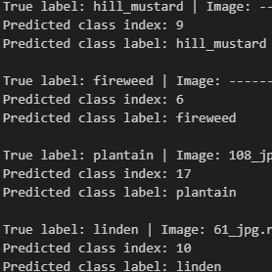

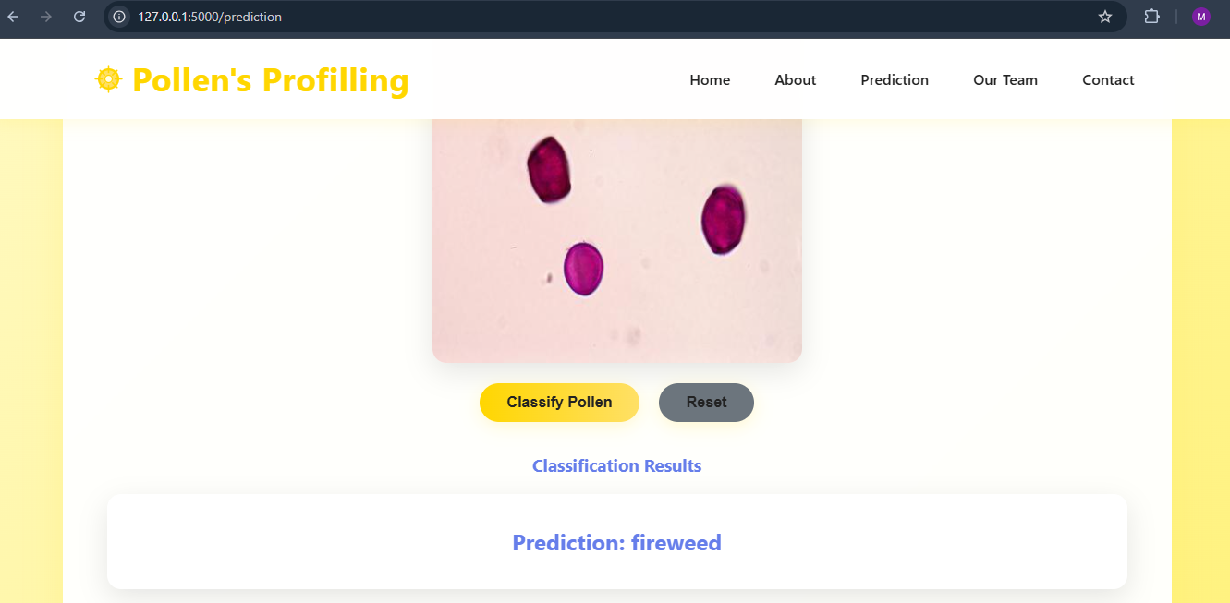

1. **ADVANTAGES & DISADVANTAGES**

✔️ **Advantages:**

* Saves time
* Accurate predictions
* Easy to use

✔️ **Disadvantages:**

* Depends on dataset quality
* Needs internet if deployed online
* Misclassification if image quality is poor

1. **CONCLUSION**

Pollen’s Profiling is a deep learning-based project that automatically identifies and classifies pollen grains from images. It replaces manual identification, which is slow and requires expert knowledge. The system uses a CNN model to predict the type of pollen quickly and accurately. It also includes a simple web interface where users can upload images and get instant results. This solution saves time, improves accuracy, and helps researchers, students, and farmers in their work.

1. **FUTURE SCOPE**

• Add more pollen types

• Convert to a mobile app

• Use advanced AI models

• Deploy globally with cloud hosting

1. **11. APPENDIX**

Source Code(if any)

Dataset Link https://www.kaggle.com/datasets/nataliakhanzhina/pollen20ldet?utm_source=chatgpt.com

GitHub & Project Demo Link

https://github.com/EduriMaryJones/Pollen-s-Profiling-Automated-Classification-of-Pollen-Grains.git